## NETWORK ADDRESS TRANSLATION (NAT) USING CISCO PACKET TRACER

## 

A Project Report

Submitted in the partial fulfillment of the requirements for the award of the degree of

# Bachelor of Technology in

Department of Computer Science and Engineering

By

* NAVADEEP – 2010030313
* SIDDARTH – 2010030475
* VIPUL REDDY – 2010030502
* MANOJ PERAVALLI - 2010030503

Under the supervision of

# Dr.P LALITHA SURYAKUMARI



Department of Computer Science and Engineering

K L University Hyderabad,

Aziz Nagar, Moinabad Road, Hyderabad – 500 075, Telangana, India.

March, 2022

1. **Declaration**

**Declaration**

## The Project Report entitled “<NETWORK ADDRESS TRANSLATION (NAT) USING CISCO PACKET TRACER

>”is a record of bonafide work of < NAVADEEP –2010030313 , SIDDARTH – 2010030475 , VIPUL REDDY – 2010030502, MANOJ PERAVALLI – 2010030503 >, submitted in partial fulfillment for the award of B. Tech in the Department of Computer Science and Engineering to the K L University, Hyderabad. The results embodied in this report have not been copied from any other Departments/University/Institute.

<Signature of the Students >

**Certificate**

* This is to certify that the Social Internship Report entitled “NETWORK ADDRESS TRANSLATION (NAT) USING CISCO PACKET TRACER” is being submitted by NAVADEEP – 2010030313 ,SIDDARTH – 2010030475 , VIPUL REDDY – 2010030502, MANOJ PERAVALLI – 2010030503 submitted in partial fulfillment for the award of B.Tech in Computer Science and technology(C.S.E) to the K L University, Hyderabad is a record of bonafide work carried out under our guidance and supervision.

The results embodied in this report have not been copied from any other departments/ University/Institute.

## Signature of the Supervisor

Dr LALITHA SURYAKUMARI

## Signature of the HOD Signature of the External Examiner

**ACKNOWLEDGEMENT**

First and foremost, we thank the lord almighty for all his grace & mercy showered upon us, for completing this Social Internship successfully.

We take grateful opportunity to thank our beloved Founder and Chairman who has given constant encouragement during our course and motivated us to do this Social Internship. We are grateful to our Principal **Dr. L. Koteswara Rao** who has been constantly bearing the torch for all the curricular activities undertaken by us.

We pay our grateful acknowledgement & sincere thanks to our Head of the Department **Dr. Chiranjeevi Manike** for his exemplary guidance, monitoring and constant encouragement throughout the course. We thank **Lalitha SURYAKUMARI** of our department who has supported throughout this course holding a position of supervisor.

We whole heartedly thank all the teaching and non-teaching staff of our department without whom we won’t have made this Social Internship a reality. We would like to extend our sincere thanks especially to our parent, our family members and friends who have supported us to make this Social Internship a grand success.

***ABSTRACT***

Network Address Translation (NAT) is designed for IP address simplification and conservation. NAT is similar to Classless Inter‐Domain Routing (CIDR) in that the original intention for NAT was to slow the depletion of available IP address

The names used to describe the addresses used with NAT are easy to remember. Addresses used after NAT translations are called global addresses.

**TABLE OF CONTENTS**

* 1. Introduction………………………………………………vii
  2. Literature Survey…………………………………………
  3. Hardware & Software requirements……………………...viii
  4. Implementation…………………………………………...ix
  5. Results ……………………………………………………x
  6. References………………………………………………...xi

**INTRODUCTION:**

* NAT is the process of reassigning the single IP address into a further one by altering the network address data in the IP header while they are traveling through a network towards the destination node.
* NAT works on a router or gateway and interconnects two networks with each other by translating the private addresses into the registered addresses before the data being transmitted to another network.
* NAT is having the potential to broadcast only one IP address to the public network on behalf of the entire internal network. This provisions the feature of security by efficiently hiding the overall IP address of the private network behind that solo address.

**LITERATURE SURVEY:**

* *[Network Protocols Handbook](https://books.google.com/books?id=D_GrQa2ZcLwC) (2 ed.). Javvin Technologies Inc. 2005. P. 27. [ISBN](https://en.wikipedia.org/wiki/ISBN_(identifier)) [9780974094526](https://en.wikipedia.org/wiki/Special:BookSources/9780974094526). Retrieved 2014-09-16.*
* Network Protocols Handbook is designed to help IT and networking professionals to avigate the network communication protocol territories smoothly. Highlights of the book are: Fully explains and illustrates all commonly used network communication protocols, including TCP/IP, WAN, LAN technologies Covers the latest and emerging technologies such as VOIP, SAN, MAN, VPN/Security, WLAN, VLAN and more Addresses vendor specific technologies: Cisco, IBM, Novell, Sun, HP, Microsoft, Apple, etc.
* *[“Configure Server Load Balancing Using Dynamic NAT”](https://www.cisco.com/c/en/us/support/docs/ip/network-address-translation-nat/200608-Server-Load-Balancing-Using-Dynamic-NAT.html). June 2018.*
* Users that access the local server from outside Internet will access the server using a single URL or IP address, however the NAT device is used to load share the user traffic to multiple identical servers with mirrored content.
* *[“K7820: Overview of SNAT features”](https://support.f5.com/csp/article/K7820). AskF5. August 28, 2007. Retrieved February 24, 2019.*
* A Secure Network Address Translation (SNAT) is an object that maps the source client IP address in a request to a translation address defined on the BIG-IP device. When the BIG-IP system receives a request from a client, and if the client IP address in the request is defined in the origin address list for the SNAT, the BIG-IP system translates the source IP address of the incoming packet to the SNAT address

**SOFTWARE AND HARDWARE REQUIREMENTS:**

OS : Windows RAM: 8.00 GB

Processor: Intel Core 5

System-type: 64-bit OS

Version: 20H2

Edition: Windows 10 Tools : Cisco Packet Tracer

**METHODOLOGY:** There are three methods in Network Simulation

i) Static NAT (SNAT)  
 ii) Dynamic NAT (DNAT)  
 iii) Port Address Translation (PAT)

**Static NAT**When using SNAT, a single internal (private) address is mapped to a single external (public) address. This type of implementation is most commonly used when a device inside a privately addressed network must be accessible directly from the Internet.

**Dynamic NAT**DNAT provides the functionality of SNAT, but with a pool of addresses that are not device-specific

**Port Address Translation**PAT offers a method that can be configured statically or dynamically, but in either case it provides a solution to the address exhaustion problem, by allowing multiple devices to use the same external IP address at the same time. This technique works primarily by taking advantage of Layer 4 TCP and UDP port numbers. The source port number is altered and mapped for each outgoing connection; in this way, any returning traffic to that specific port can be mapped to the correct internal address

**FLOWCHART:**

**IMPLEMENTATION**

Here we have implemented this by using Cisco Packet Tracer .Firstly we have taken 3 PC’s and then we took 2 switches and 2 routers and for each router we connected a switch and then 2 pc’s then we have configured the pc’s with various ip addresses and we have given default ip address for each router and we have configured all the routers and we have added all the ip addresses to the RIP table .

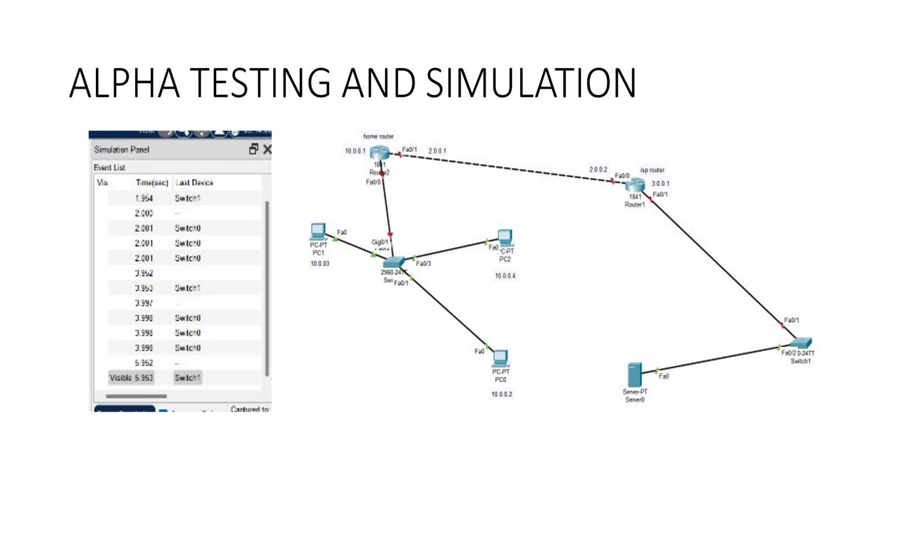

**RESULT:**

**OUTPUT SCREENS:**

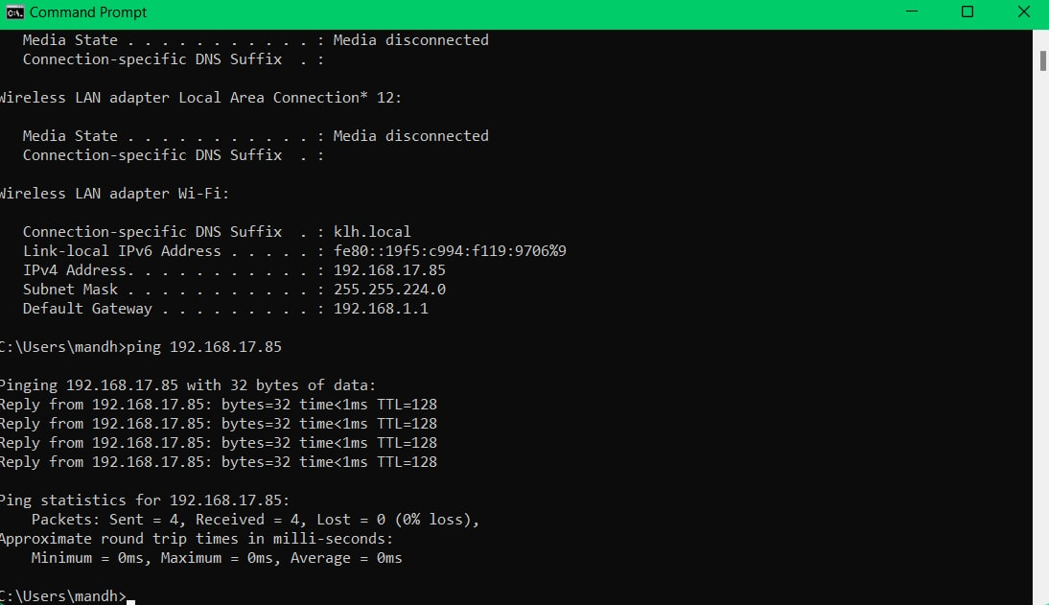

**CONCLUSION:**

Network address translation, when used appropriately, is a valuable resource to managed service providers. It can be used to direct traffic as needed and helps to conserve IP addresses in the public space. While there are different types of network address translation based on need, there are tools to use and security considerations to be made for each case.  
Now that we’ve made network address translation easier to understand, this is a great time to do a little research to see how it can be better used to help your managed service provider and its clients today.